# Exemplar: Adding an aggregation

## **Overview**

In the exercise *Creating an aggregation*, you were asked to create and manage an aggregation in Power Query editor to reduce the data size of the Fact table and optimize query performance.

Your tasks in the exercise include:

* Create an aggregation based on the Fact table (Sales table) according to the required granularity.
* Configuring the data types of the aggregated columns and the source columns.
* Manage the aggregation in Power BI desktop.

This reading provides you with a step-by-step guide for completing these tasks. It also includes screenshots that you can compare against your work.

You can also review the [*Creating an aggregation*](https://www.coursera.org/learn/data-modeling-in-power-bi/lecture/6BHay/creating-an-aggregation)and [*Managing* *aggregations*](https://www.coursera.org/learn/data-modeling-in-power-bi/supplement/bZTJ6/managing-aggregations)videos.

## **Step 1: Download the Adventure Works Power BI project.**

1. Download and save the file Adventure Works.pbix*.* Load the data from the workbook into Power BI. Select the Preview pane to open a table preview. The data model has three tables of data: Sales, Products, and Date.

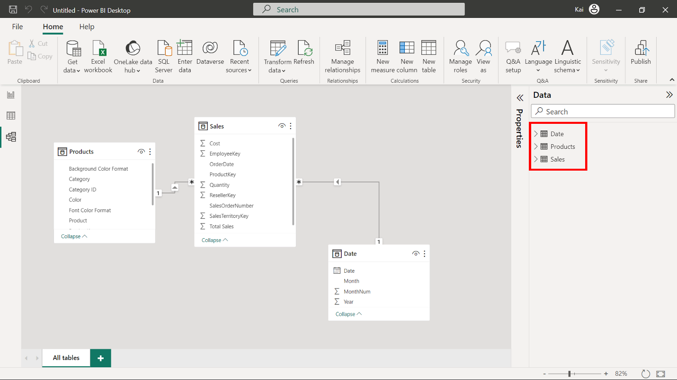

1. Download and save the Excel spreadsheet Adventure Works Data.xlsx.
2. Next, select on File in the top-left corner of the screen. In the dropdown menu, hover over Options and settings, and then select Data source settings.

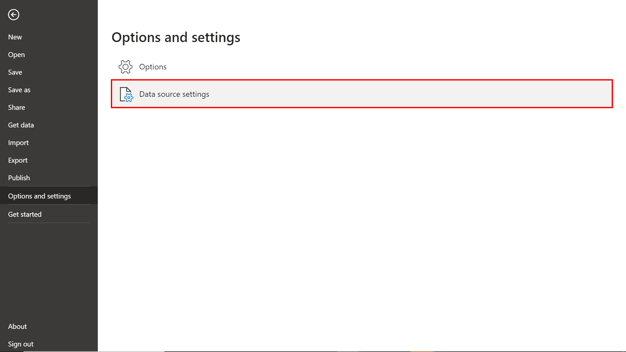

1. A new window titled Data source settings will appear. Here, you'll see a list of all the data sources currently used in your Power BI reports.
2. After selecting the data source, click on Change Source... to modify its details. Navigate to the file location of the Adventure Works Data spreadsheet.

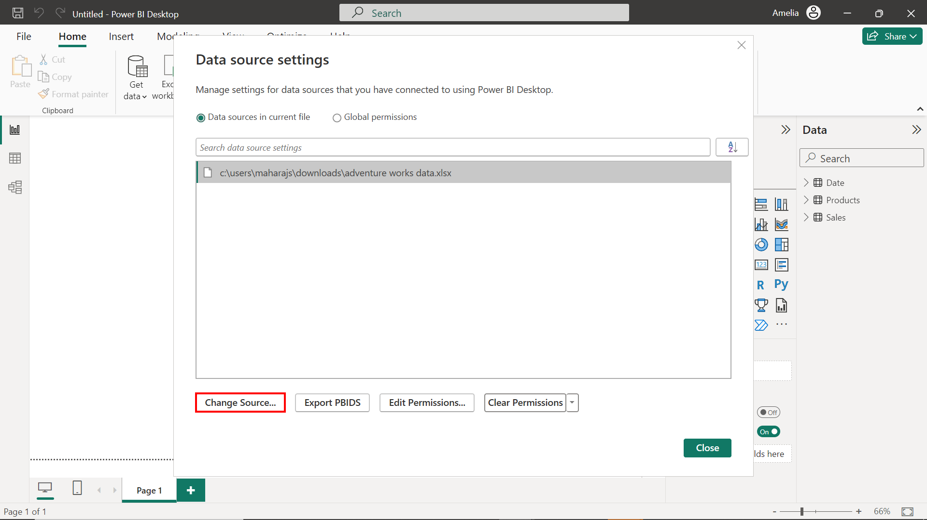

1. Once you’ve made the necessary changes, select OK to confirm and Power BI will validate the new connection.

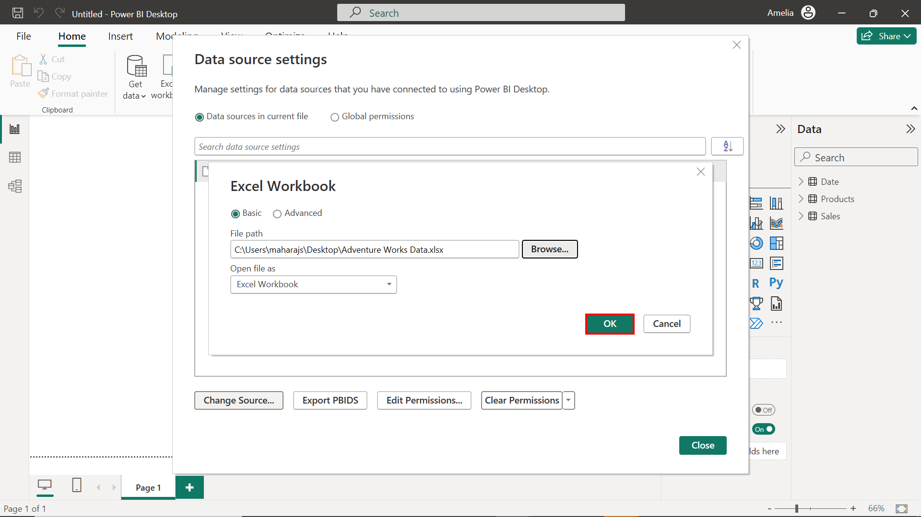

## **Step 2: Create an aggregated table named SalesAgg**

1. On the Home tab, selectTransform data and then Transform data from the drop-down menu.

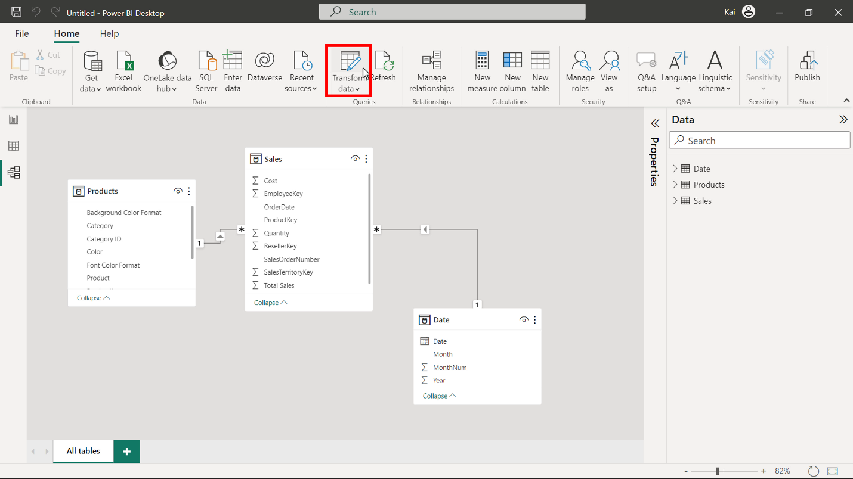

1. In the Power Query editor window, select the Sales table from the Queries pane on the left and right-click to open the context menu. Select Reference to duplicate the table. Use right-click again to re-open the menu.

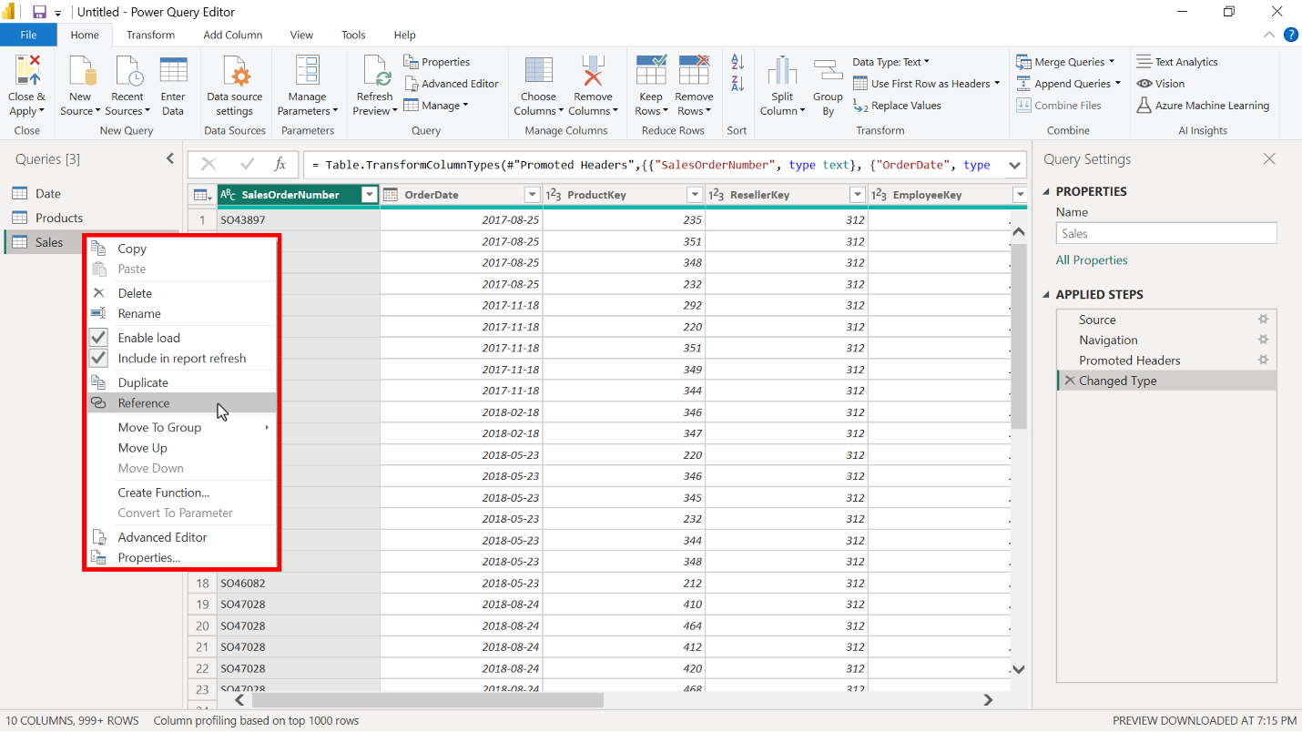

1. In the Rename field, rename the new table to SalesAgg. Duplications save the original tables for other analytics needs. So always copy the source table and create an aggregate from the duplicate copy.

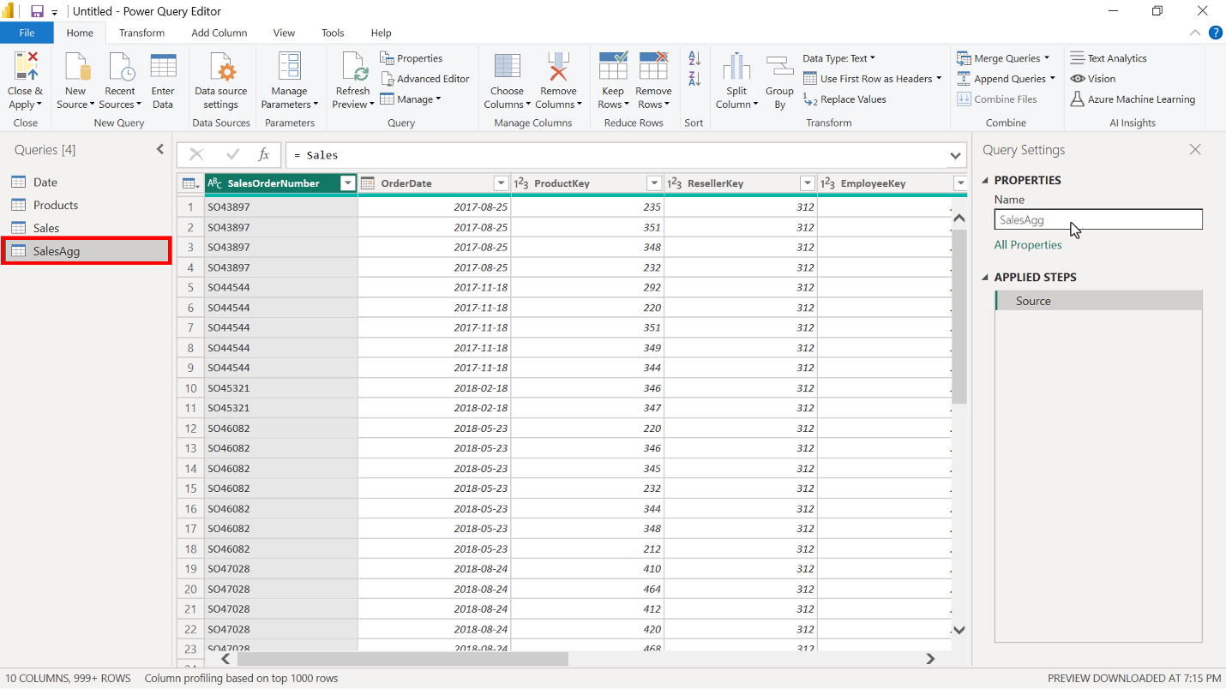

1. Choose the columns that you want to keep in the aggregated table from the source table by selecting the Choose column option on the Home tab in the Power Query editor window.

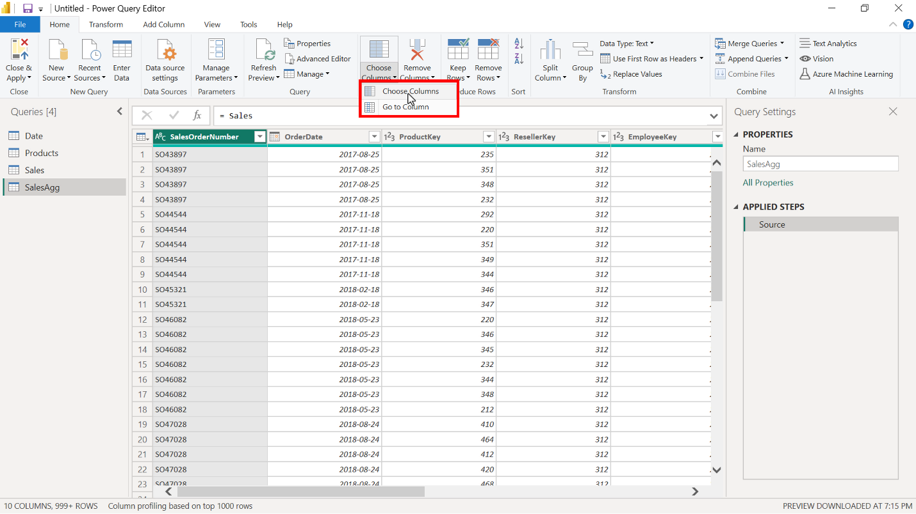

1. In the Choose column window select the following columns:

* OrderDate (This column is added to group data and will be used for the group by step)
* Total Sales
* Quantity
* Cost

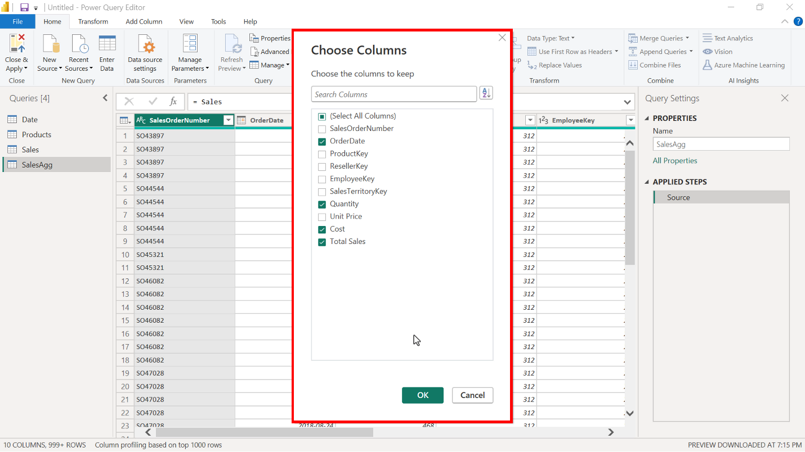

1. Next, select the Transform tab in the Power Query editor window and then Group by. This opens the Group by window, where you can define aggregate columns and mathematical operations to compute the aggregation.

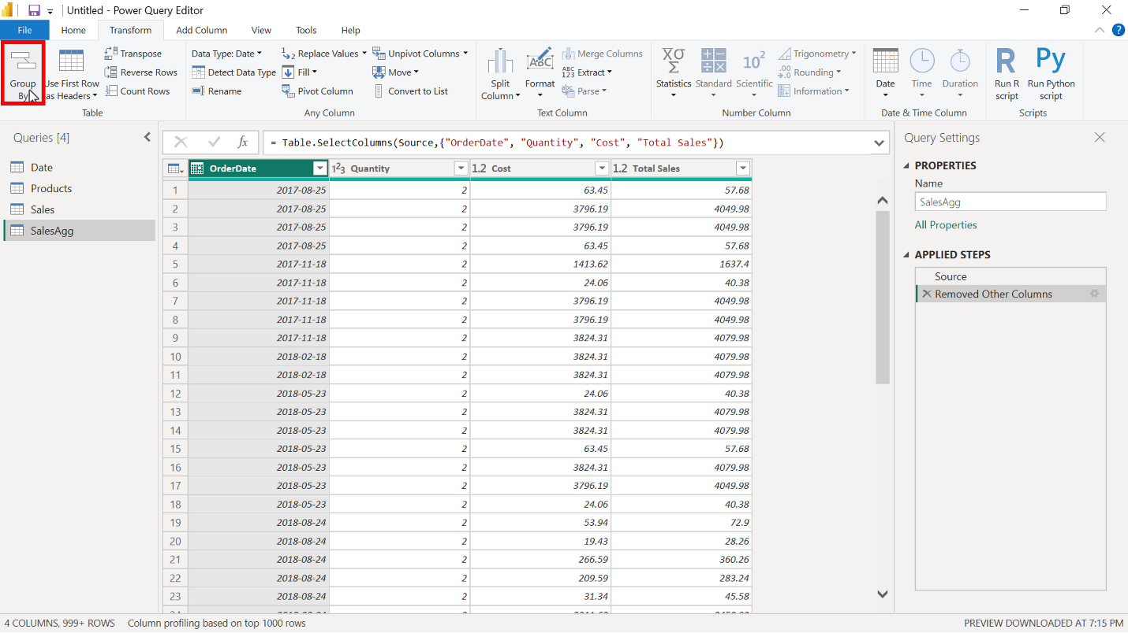

1. Group the aggregation by the OrderDate field in the Group by window.

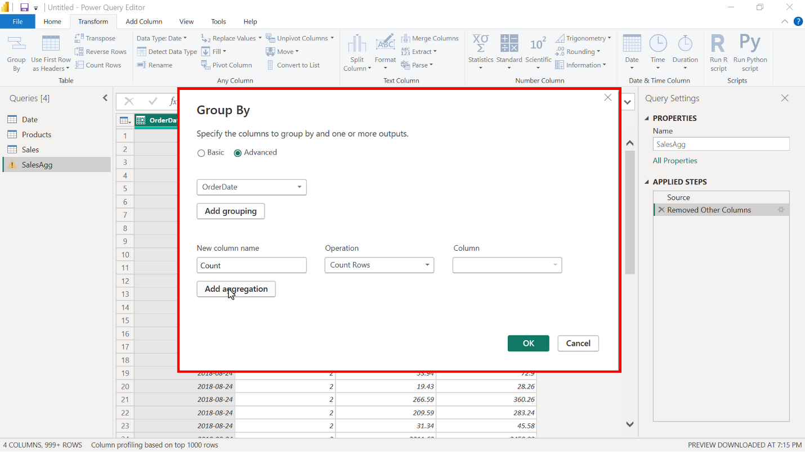

1. Create the following aggregate columns in the Group by window:

* TotalQuantityCount that uses the Count function as an operation.
* SumTotalSales, which performs a Sum as a mathematical operation and uses Total Sales as the column reference.
* SumCost also uses the Sum function and Cost as the column reference.

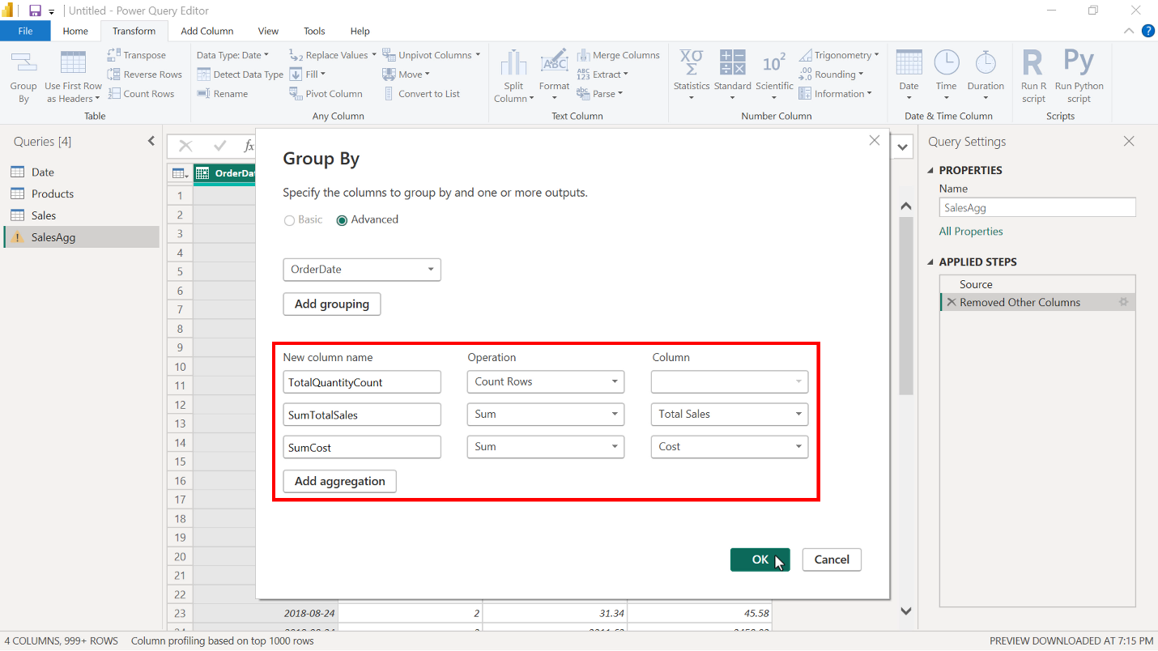

1. Select OK to apply all changes to the aggregation.

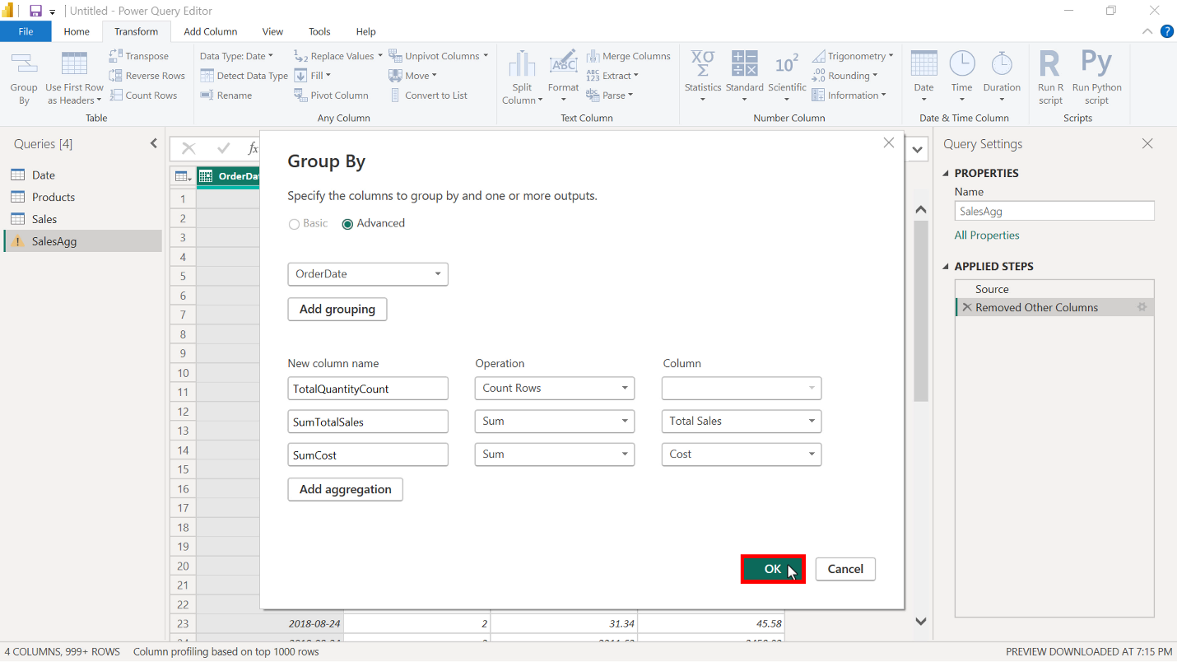

1. Select Close and apply on the Home tab to close the Power Query editor and return to the Microsoft Power BI desktop interface.

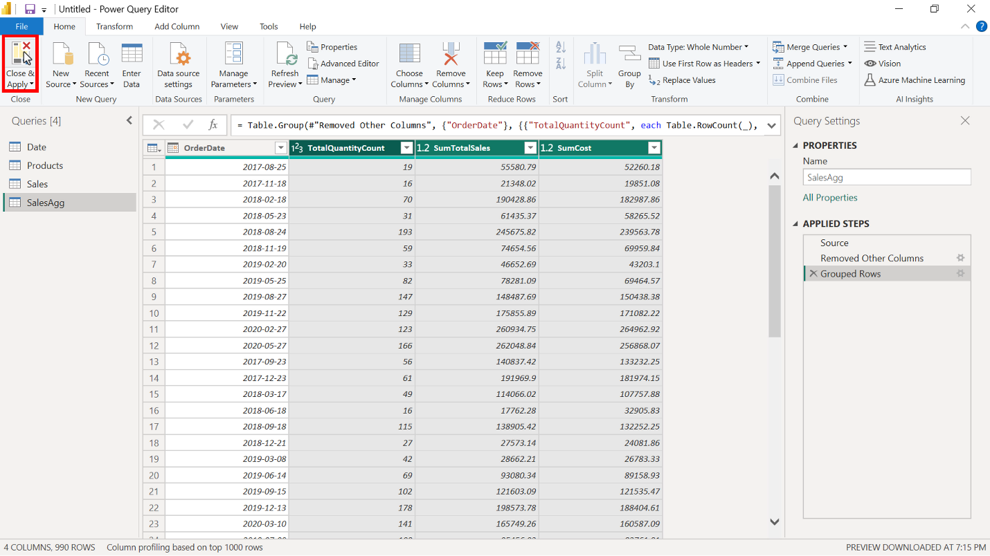

1. Select the table from the Data pane to display the total number of rows. In the Sales table, the number of rows is 57851. The number of rows in the SalesAgg aggregated table is only 990, which is 1.71% of the original rows, a significant reduction in data size.

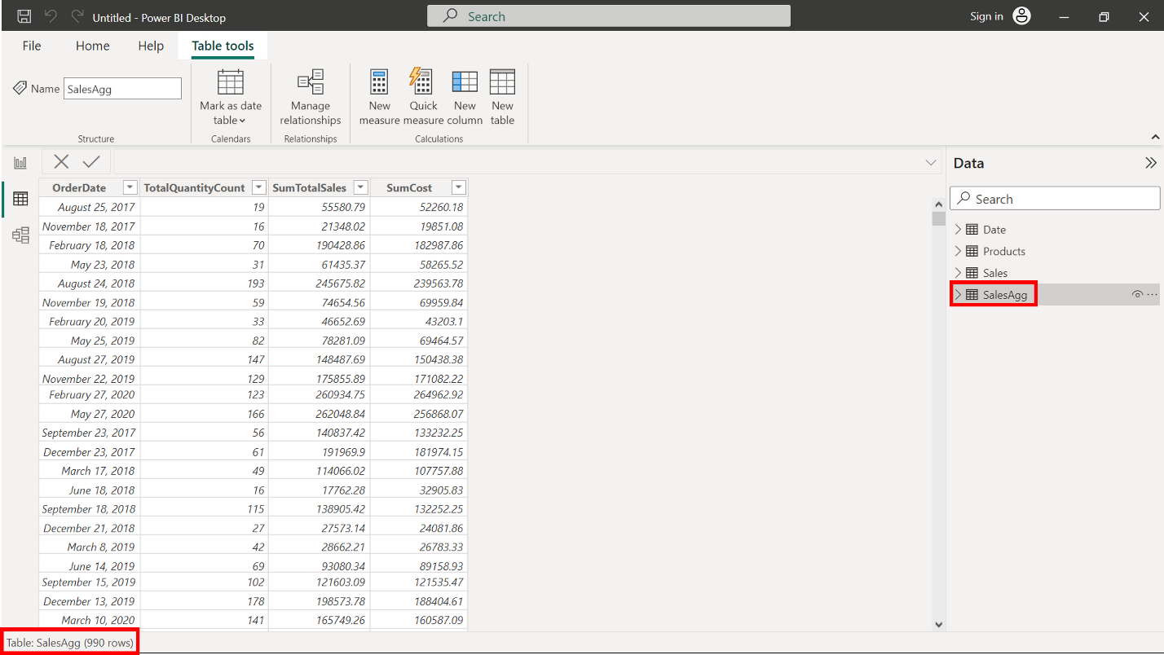

## **Step 3: Establish relationship and manage aggregation in Power BI.**

1. The new aggregated SalesAgg Fact table does not have a relationship with the Date table. Switch to Model view and establish a relationship between the two tables based on the OrderDate field.

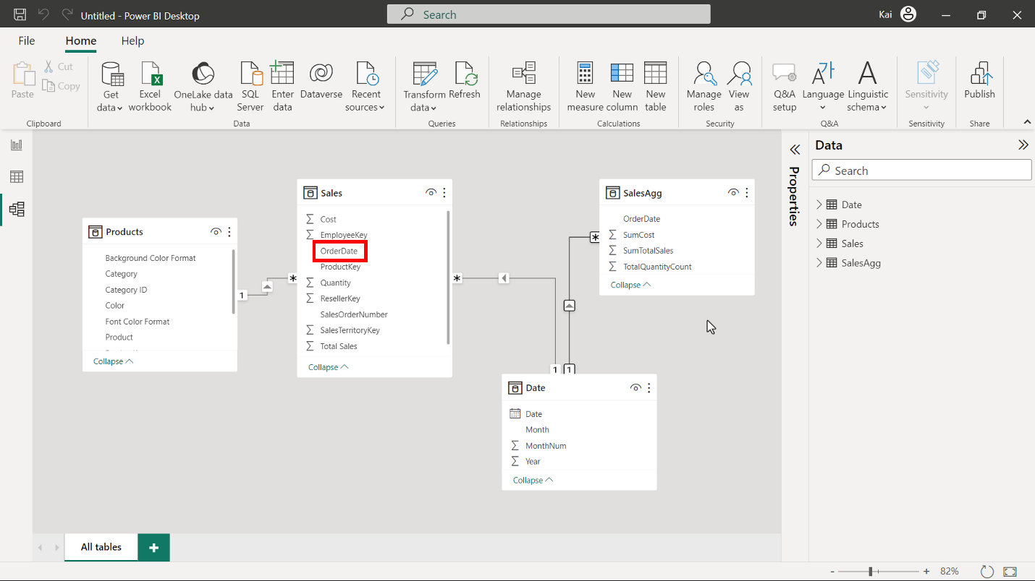

1. Open the Power Query editor again to ensure that the data types of the aggregate columns match the data types of the source columns as follows using the Data type icon to the left of each column:

* The data type of the column using Count must be set to Whole number.

The data type of SumTotalSales and SumCost must be Fixed decimal number.

You can change the data type by selecting the Data type icon on the left side of the column name in the Power Query editor. Once you have completed the data type configuration, select Close and apply to return to Power BI desktop interface.

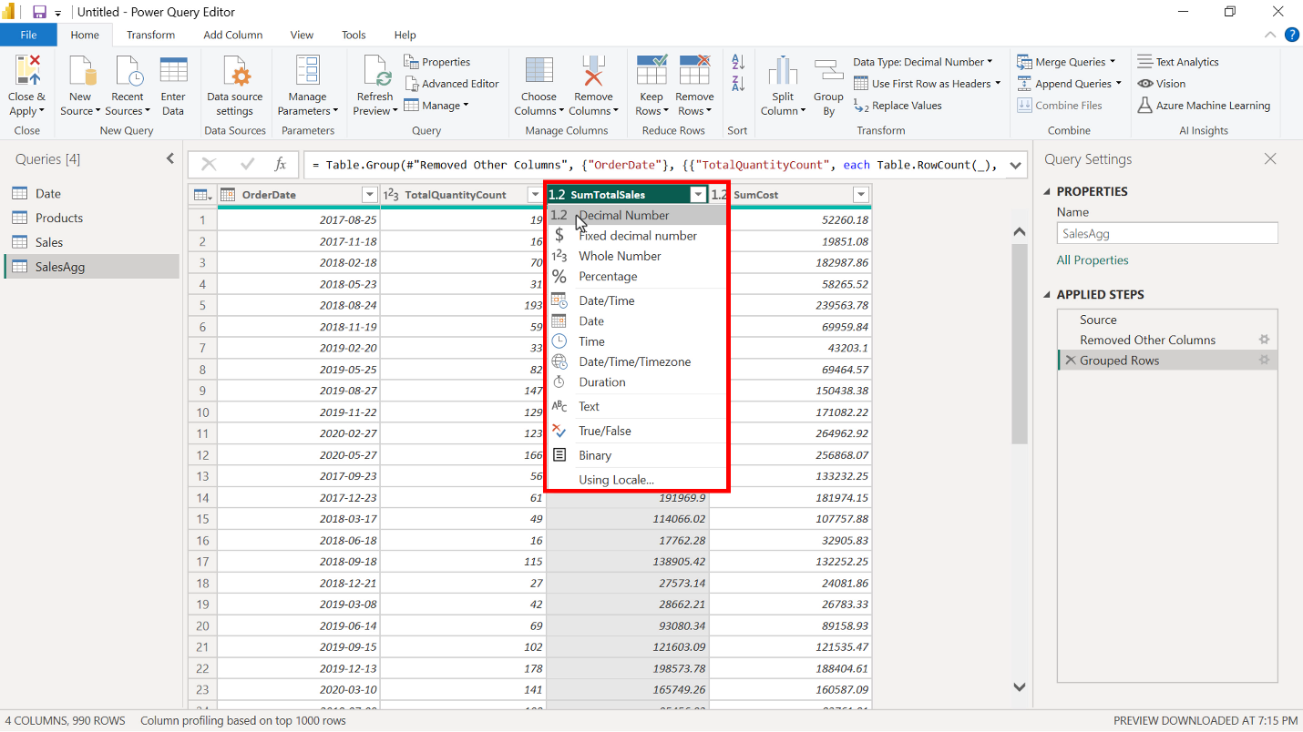

## **Step 4: Save the Power BI project.**

* Save the Power BI project to your local computer.

To save the project, open the File menu, select Save As, and provide an appropriate name for the project along with a path to the folder on your computer.

## **Conclusion**

With these steps, you have successfully created and configured an aggregation within the data model of Microsoft Power BI to reduce the data size significantly. You are now in the situation to help Adventure Works optimize the query performance and enhance user experience while interacting with the reports and visualizations.